**Phase 3 : Project Development Part 1**

**Project title:**

Machine learning model deployment with IBM cloud Watson Studio.

**Problem Statement:**

Become a wizard of predictive analytics with IBM Cloud Watson Studio. Train machine learning models to predict the outcomes in real time. Deploy the models as web services and integrate them into your applications. Unlock the magic of data driven insights and make informed decidions like never before.

Contents of the document:

* Project overview
* Data Understanding
* Data Visualization
* Data Preparation

1. Modeling
2. Evaluation

**Project Overview:**

House Price Prediction Analysis aims to use Machine learning analysis algorithms to predict the price of houses based on their features like number of rooms, number of bedrooms, age of the house, population of the respective area where the house is located, location of the house and the area income with other relevant factors if available.By this Machine Learning model user can predict the price of the house that can be sold.

**Step wise process for the House Price Prediction Analysis Machine learning model deployment.**

**Step 1:** Login to IBM cloud

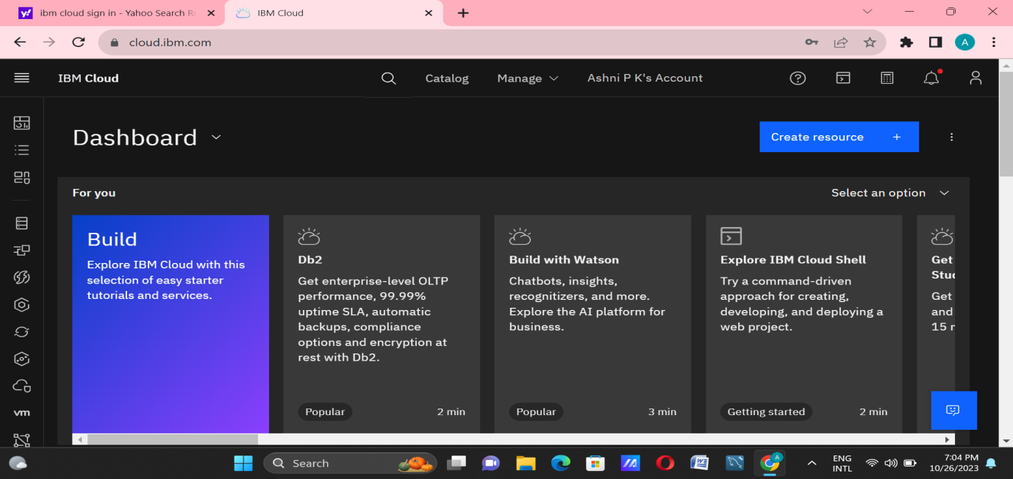

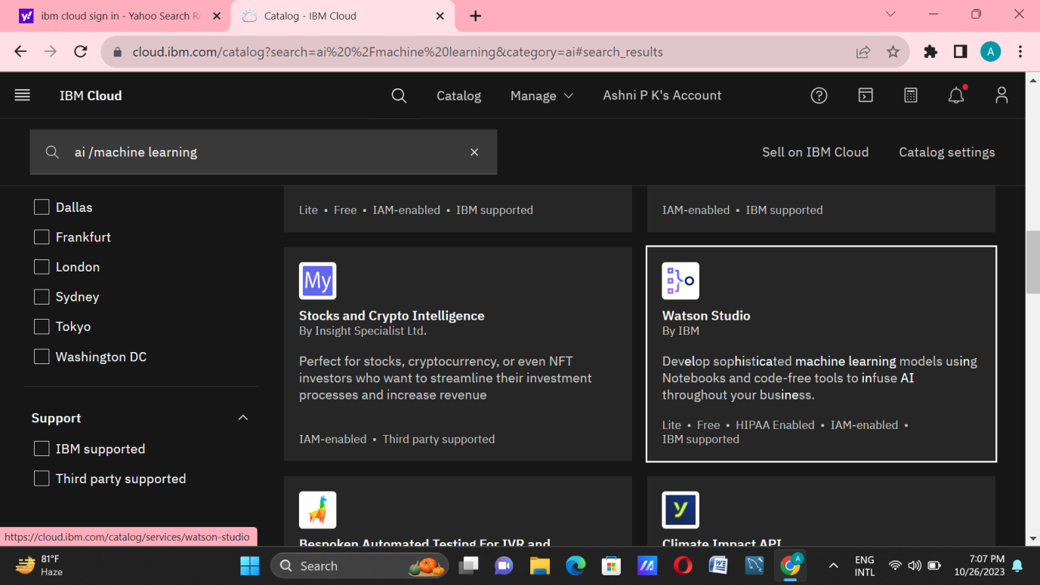**Step 2:** Go to catalog and create a Watson Studio service in AI category.

**Step 3:** Get started to launch Watson Studio Dashboard.

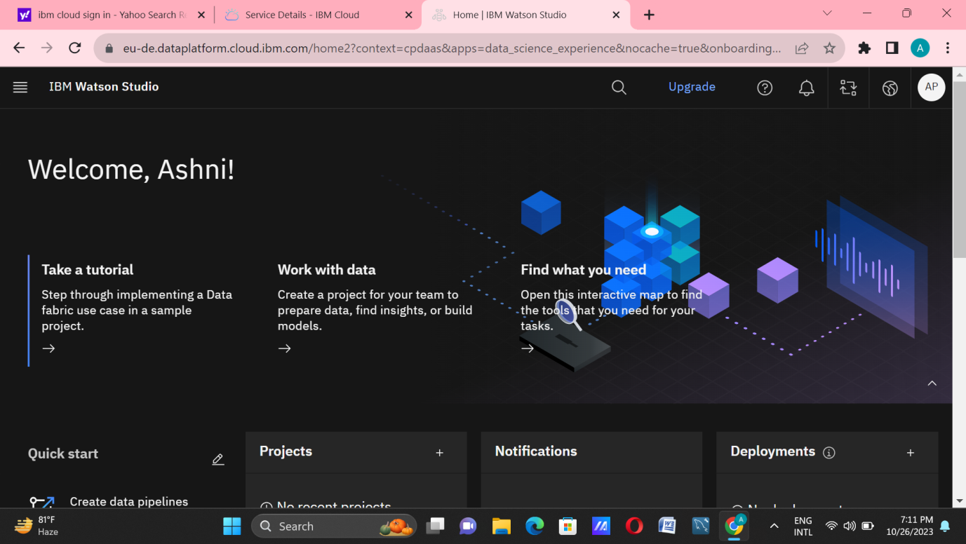

IBM Watson Studio is an IDE to build ,run and manage AI models.The platform consists of a workspace that includes multiple collaboration and open-source tools for use in data science.

**Step 4:** Create a project in IBM Watson Studio in IBM Cloud and assign a Cloud object storage to manage datasets.

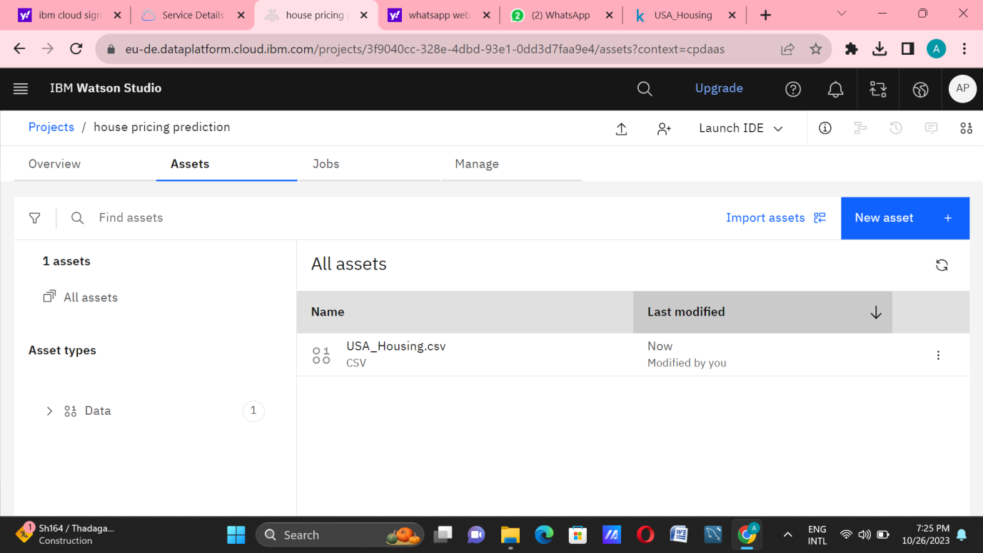

Cloud Object Storage is a storage service in IBM Cloud. IBMCloud Object Storage is a highly scalable,designrd for high durability,resiliency and security.We use this service to manage our datasets for training the ML Model and store required files.

**Step 5:** Add a jupyter notebook instance in your project to Develop and Deploy Machine Learning Model.

1. Import necessary library packages.

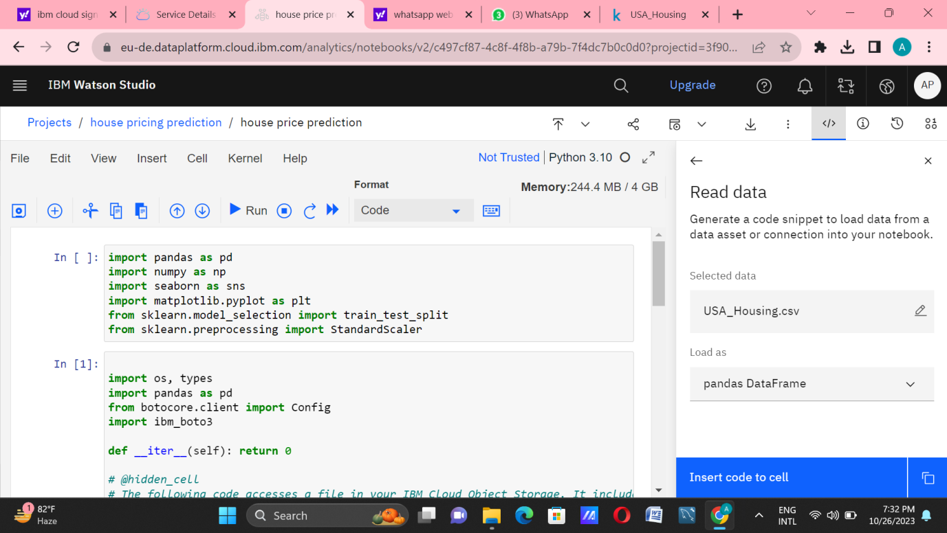

ii.Import dataset and proceed further with pre-processing steps and build the model.

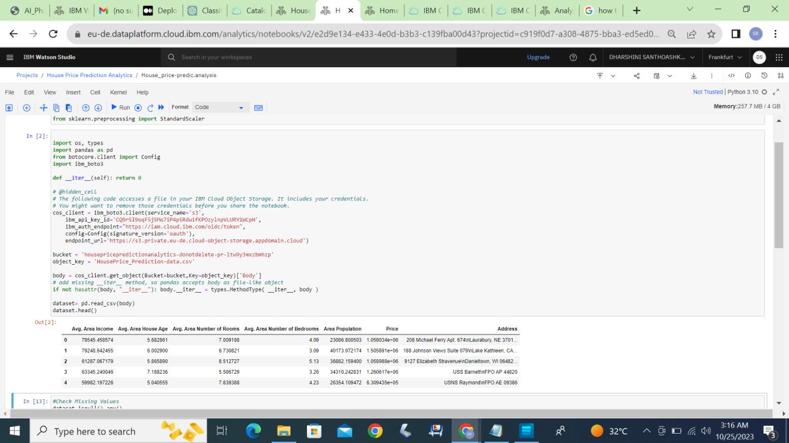

**Step 6:** Train the build model and evaluate them.

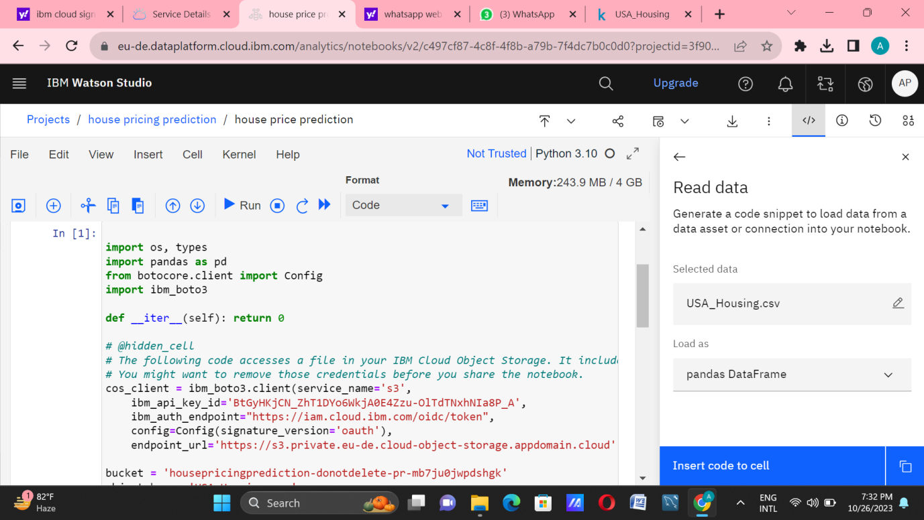

Model was build trained and tested.